CATEGORY: LIPS

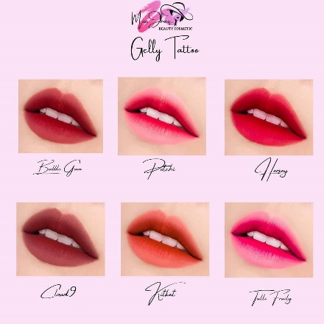

PRODUCT NAME: GELLY TATOO

PRICE: 160 Php

DESCRIPTION:

Shades:

* Potchi
* Kitkat
* Tutti fruity
* Bubble gum
* Hersey
* Cloud 9

The Gelly-Tattoo is everything your lips been waiting for. It gives that healthy blush look on make up as well and its highlights the natural lip color. If you want to use it as a blush, you can too and it's looks beautiful. Just apply 2 or 3 drops that are already enough for you to rock.

* Pigmented
* Shade range
* Easy to use
* Affordability
* Lip and cheek nourishment

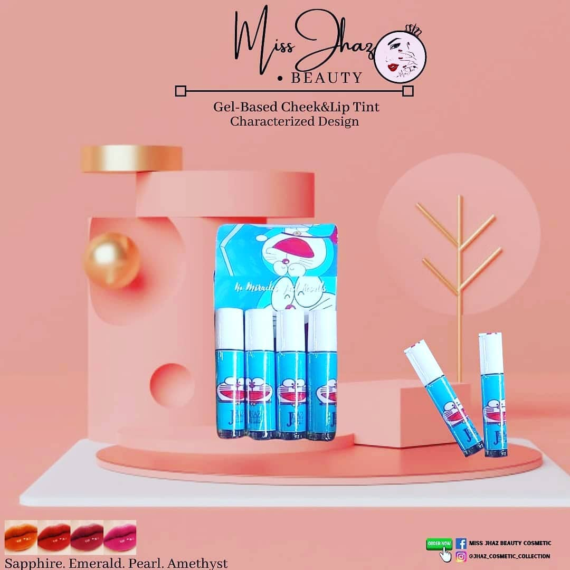

PRODUCT NAME: CHARACTERIZED CHEEK and LIP TINT

PRICE: 120 each/ 299 set

DESCRIPTION:

Shades:

* Sapphire
* Amethysts
* Pearl
* Emerald

Benefits

* Cruelty free
* Paraben Free
* Safe for lactating Mom
* Safe for the kids
* Lightweight and easy to blend
* Long Lasting Stain
* FDA APPROVED manufacturer.

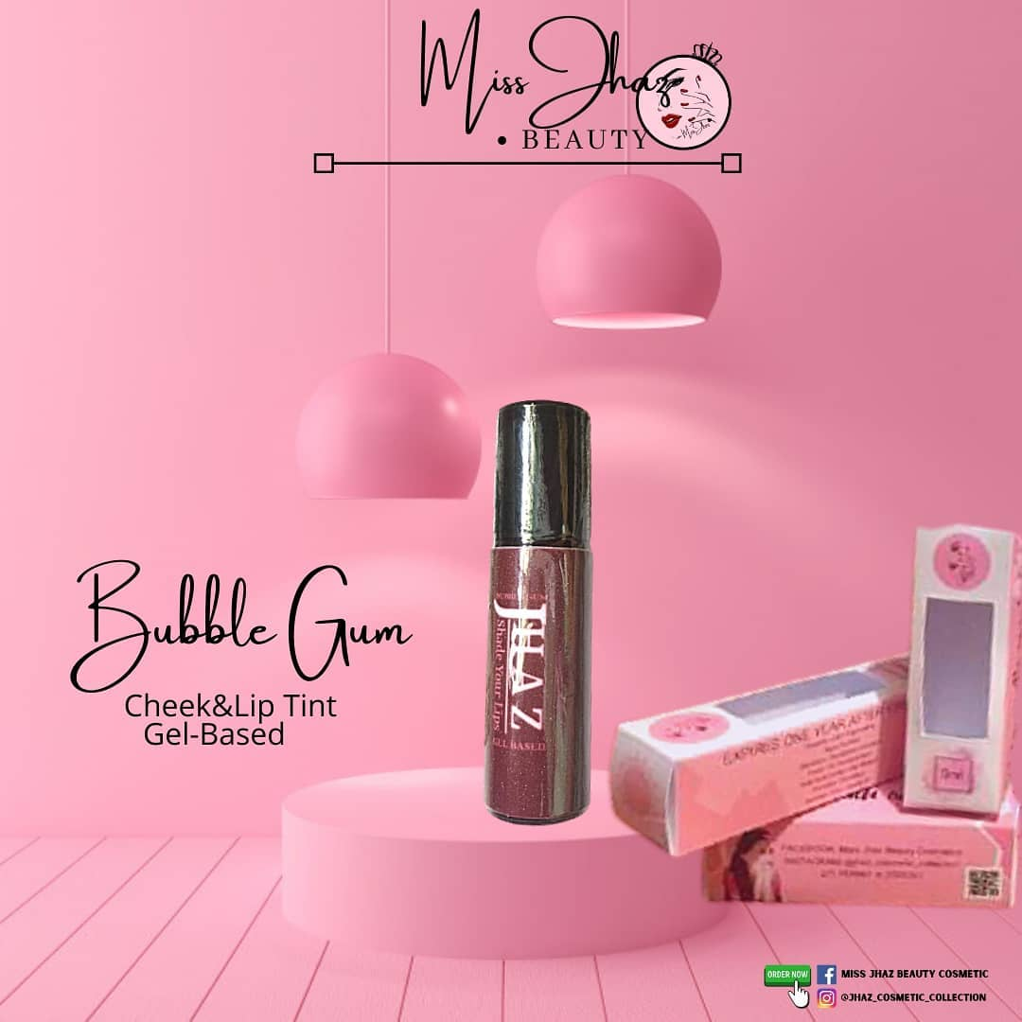

PRODUCT NAME: CHEEK and LIP TINT

PRICE: 50 Srp (30% clearance sale)

DESCRIPTION:

They comes in these different shades with great pigmentation.

Shades:

* Potchi
* Kitkat
* Tutti fruity
* Bubble gum
* Hersey
* Cloud 9

Benefits:

* 100% satisfaction guarantee!
* Natural ingredients
* Water proof
* Sweet scent
* Roller applicator
* Blend able
* Safe for kids & pregnant women
* Recommended
* Affordable
* FDA approved

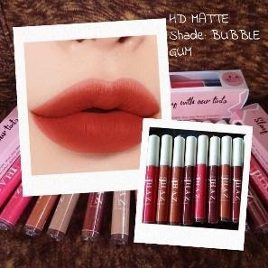

PRODUCT NAME: HD MATTE

PRICE: 50 Srp (30% clearance sale)

DESCRIPTION:

Shades:

* Potchi
* Kitkat
* Tutti fruity
* Bubble gum
* Hersey
* Cloud 9

These handy slim, trendy HD Matte Tints ensure long lasting effects that doesn’t smudge and is transfer resistant

Benefits:

* 100% original brand direct from manufacturer
* FDA approved ingredients
* Super Matte.
* Highly pigmented grade quality.
* Long lasting Matte lip tint.
* Looks fresh 24 hours.
* Smudge proof.
* Best for all skin type.
* Water proof.
* Organic
* Cherry Scent

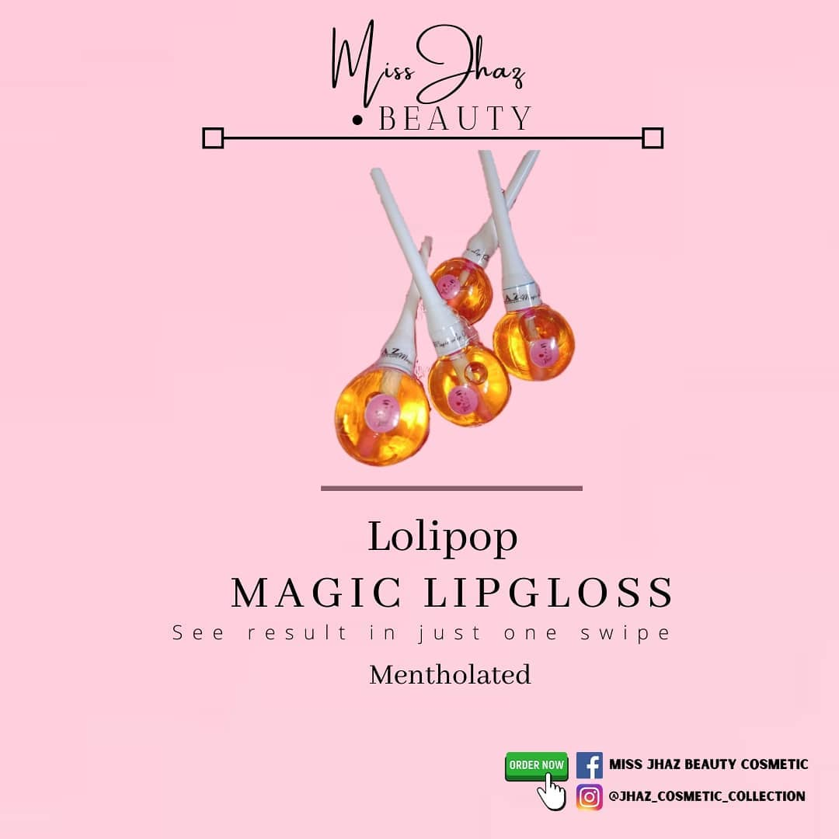

PRODUCT NAME: MAGIC LIPGLOSS

PRICE: 110 Php

DESCRIPTION:

The most gorgeous shades of lip glosses that can be worn on their own, or even more magical when layered on top of a lipstick! The color depends on your body temperature.

Gives you a glossy fresh and luster effect, it changes the color depending on your body temperature. It may be light pink to dark pink transition.

Benefits:

* Olive oil - protect your lips from drying out
* Vitamin e oil - helps to repair and improve the appearance of the lips
* Almond oil - cures the chapped lips
* Coconut oil - helps to replenish & exfoliated lips
* Sunflower oil and aloe Vera - lighten the dark lips
* Citric acid - adjust the products ph. level.

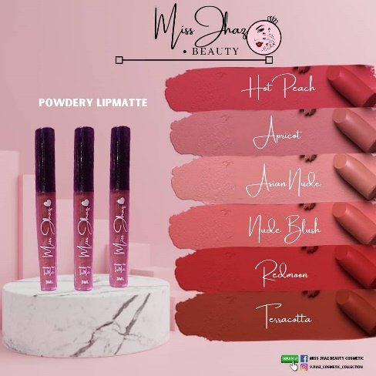

PRODUCT NAME: POWDERY LIPMATTE

PRICE: 160

DESCRIPTION:

Shades:

* Hot peach
* Apricot
* Asian nude
* Terracotta
* Nude blush
* Red moon

MJBC POWDERY LIPMATTE is a matte liquid lip tint with a creamy rich texture and high intensity of pigmented color that dresses the lips with intense hydration and antioxidant care.

In just one stroke you get a full coverage color application, with a smooth matte finish. It gives the lips a barely-there feel.

Benefits:

* It is long lasting. Matte lip matte stick to your lips longer than their glossy counterparts.
* It looks natural.
* It is smudge-free.
* It is stick-free.
* It can be worn without any other makeup.
* It can be worn even during the summer.
* It can give you a look that is uniquely you.
* It defines your face.

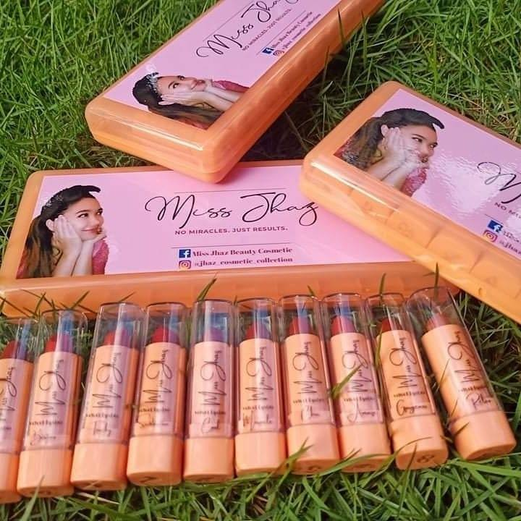

PRODUCT NAME: VELVET MATTE LIPSTICK

Price: 40 SRP per piece (30% clearance sale)

DESCRIPTION:

The Velvet MATTE Lipstick has high intensity pigment for a full coverage lip. This long wearing, ultra-pigmented liquid lipstick contains moisturizing ingredients that glide on for a creamy matte look that does not dry down.

10 Shades in 1set

Benefits:

* Very Pigmented
* Good Quality
* Cute Size (3g/each)
* Peach Casing
* Fruity Scent

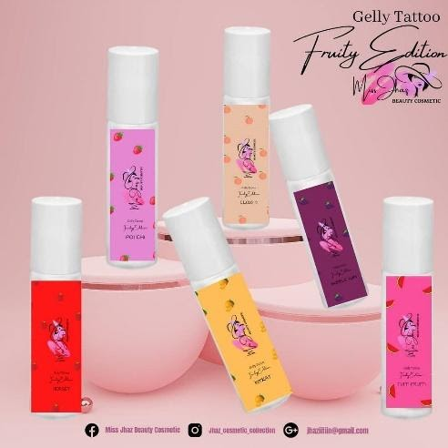

PRODUCT NAME: GELLY TATTOO FRUITY EDITION

Price: 130 Php

DESCRIPTION:

Gelly-Tattoo tints organic safe for kid’s pure organic 100%‼️

Cheek, lip and eyelid tint

BENEFITS:

* With vitamins E, A & C
* Lightens dark lips
* Softens dry lips
* Heals cracked lips
* Treats mouth ulcers/rashes
* Removes dead skin cells
* Delays sign of aging
* Prevents flaking/bleeding
* Prevents irritation
* Lip & cheek moisturizer
* Removes cheek blemishes
* Made from High Grade FDA approved laboratory.
* Clinically Tested.
* Safe for eyelids.
* Hypo-allergic.
* Safe for kids.
* Safe for pregnant.
* No Harmful Chemicals.
* Colorants derived from organic powdered fruit tints.

With food grade vegetable glycerin, food grade rosewater, vitamin E, A and C, melon scent and herbs for healing, organic colorants used.

Switch to organic beauty products.

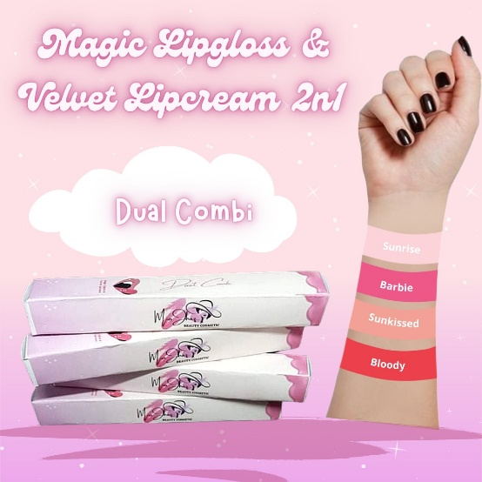

PRODUCT NAME: VELVET LIP CREAM MAGIC LIP GLOSS 2N1

Price: 170 Php

DESCRIPTION:

Shades:

* Sunshine
* Sunrise
* Bloody
* Barbie

New released Velvet Lip cream with Magic Lip-gloss in 1 bottle ( dual combi) now in 4 variants of shades available from semi-nude to bold, which is definitely always match for your everyday wear. Explore your style and look what you want.

Say yes to velvety goodness. Nourish your kissers with our extra hydrating velvet lip cream, which protects and conditions with Vitamin E and camellia oil. One swipe is all you need for full, creaseless coverage-you get a beautiful solid hue with a smooth satin finish every single time.

Benefits:

* Intense pigment
* Impeccable color payoff with every swipe
* Semi-matte, semi-satin finish
* Creaseless coverage with a comfortable, creamy finish
* HYDRATING
* Enriched with Vitamin E and camellia oil to nourish and moisturize